Datasheet Values:
Watch out for:

Pico 2:
Voltage on VSYS pin (from a main power input) = 1.8-5.5v,
for supply voltage test in step 3.1
Voltage on 3v3 pin + current availability = boards 3.3v input, keep total load under 300mA,
powers knobs + knob reading board Voltage on VBUS pin (5v from the cable) = 5 V ± 10%., powers amplifier
Link between VBUS and VSYS = one way diode lets cable 5v supply feed into VSYS,
Used with second power source fed through another diode so supply’s don’t fight in step 3.1 supply voltage test, built in, nothing to wire.
5V signal on input/output pins = not safe,
Treat every pin as 3.3v only, never connect 5v rail to signal pin
Signal voltage of input/output pins = 3.3v,
connecting anything above is damaging
Pins able to read analogue voltages = GP26-GP28 0-3.3v 30mV offset so account in code,
Mustn’t go more than 0.3v above 3.3v, backup plan for pitch knobs
Analogue reference + ground pins = ADC_VREF + AGND pin 35 and 33
Onboard light pin = GP25, for blink test in step 1.3
How to power from external supply = plugin a micro-usb ,
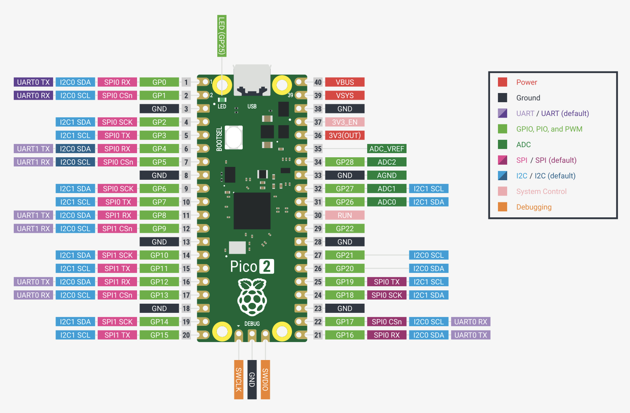

MCP602 amplifier:
Supply voltage = 2.7-5.5V, Normal working conditions
Max supply voltage = 7V
Max voltage on any pin = 0.3 below ground to 0.3 above supply, so −0.3 to 5.3 V on a 5 V supply. This is the damage limit: never go past it.
Current per amplifier = 230 µA, Normal working conditions
Gain bandwidth = 2.8 MHz, normal working conditions. Borderline for the filter at 10 kHz cutoff and maximum resonance (rule 18).
Slew rate = 2.3 V/µs (check in the datasheet). The filter needs about 0.15 V/µs, so it passes easily (rule 19).
Input voltage range (common-mode) = 0.3 below ground to 1.2 below supply, so about −0.3 to 3.8 V on a 5 V supply. This is the working limit: the audio at the op-amp inputs must stay between 0 and 3.8 V, which sets how big the audio signal can be (rule 17). Found in the DC Electrical Characteristics table.
Diagram:
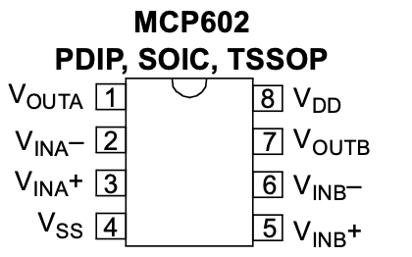

PCM5100A I2C digital-to-analogue converter board:
Supply voltage = 3.3V,
Check in Adafruit’s guide what voltage the board accepts, since it may have its own regulator.
Supply voltage for each power pin (1, 8, 20) = 3 -3.6V,
Max supply voltage = -0.3 to 3.9V, never connect 5V
Check in Adafruit’s guide whether the board has its own regulator, which would let its power pin (often labelled VIN) accept 5 volts and step it down to 3.3. If it doesn’t, power it from the Pico’s 3V3 pin.
Max voltage on the digital input pins (the three audio wires and the setting pins) = -0.3 to 3.9V
Full scale output level = 2.1 Vrms,
Sine wave’s peak is about 1.41 times its root mean square value, so the output swings from about −3 to +3 volts. The MCP602’s inputs only work between about 0 and 3.8 volts, and at maximum resonance the filter boosts the signal by up to about 14 times (gain × Q = 2.8 × 5). So the signal must be shrunk to about 1/18 (about ±0.17 V peak) and centred on 2.5 volts, not shrunk to a third. Confirm the exact ratio in step 1.7 (rule 23).
Support sample rate = 8-384 KHz,
Will use 44.1 or 48 KHz
Bit depth = 16, 24 or 32 bits,
Will use 16 bit
Smallest drive load = 1 KΩ,
Whatever you connect to the output, including the shrinking resistors, must add up to at least 1 kilohm.
Current into each input pin: 10µ
Only three wires are needed: data in (DIN), bit clock (BCK) and word clock (LRCK, also called left-right clock)
Automatic mute = It goes silent if the clocks stop or are wrong, Useful for debugging: if there’s no sound, a clock wiring or code problem is a likely cause
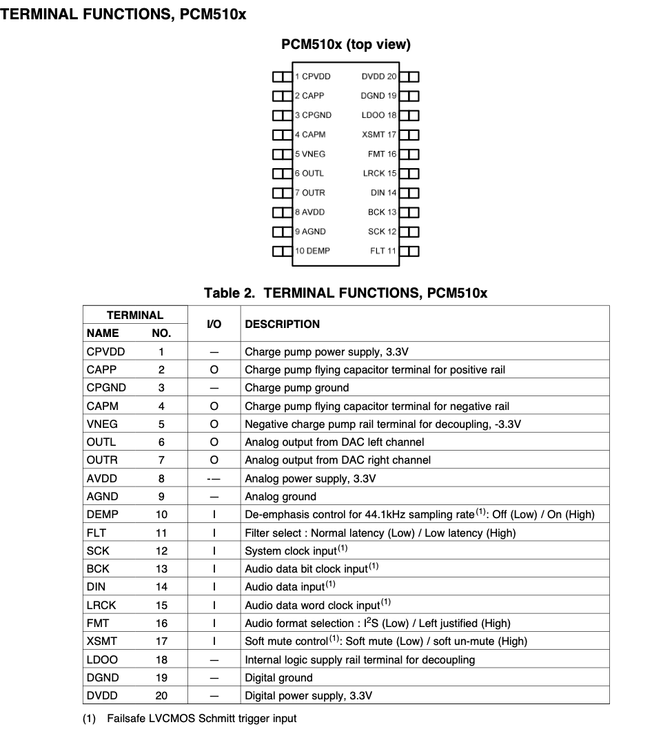

ADS7830 knob-reading board:
https://www.ti.com/lit/ds/symlink/ads7830.pdf
Supply voltage range = 2.7-5V,
Maximum input voltage range = -0.3 to 6 V,
Sample rate - 70KHz, how fast it reads the knob turning,
Reference voltage = 2.5V,
Internal 2.5 volts (power bits 1 1), or external on the reference pin (0 1)
If I choose 01 in the code: Pico’s 3.3 volt supply has a little electrical noise on it, which would make the readings flicker slightly. Code smoothing from step 2.3 handles most of that, and a capacitor between the reference pin and ground helps too, if the board doesn’t already have one.
Address byte = 1001000 binary = 0x48 with A0 and A1 at ground (range 0x48–0x4B)

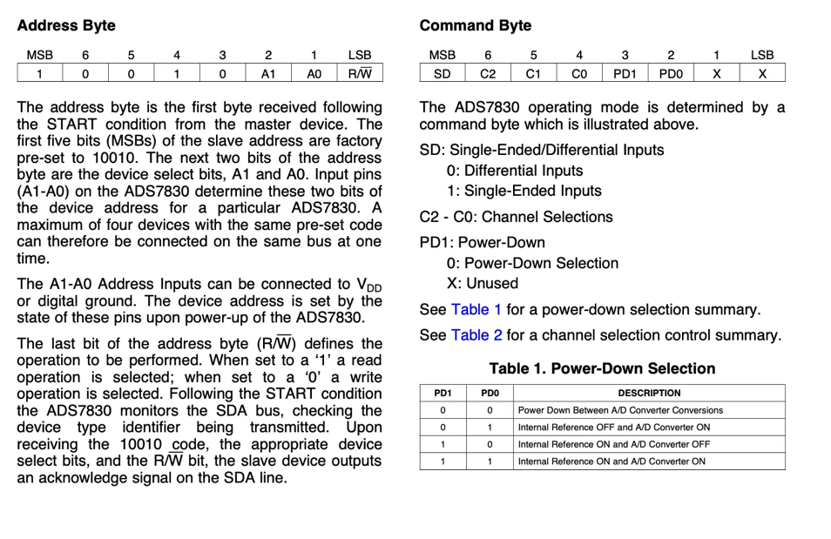
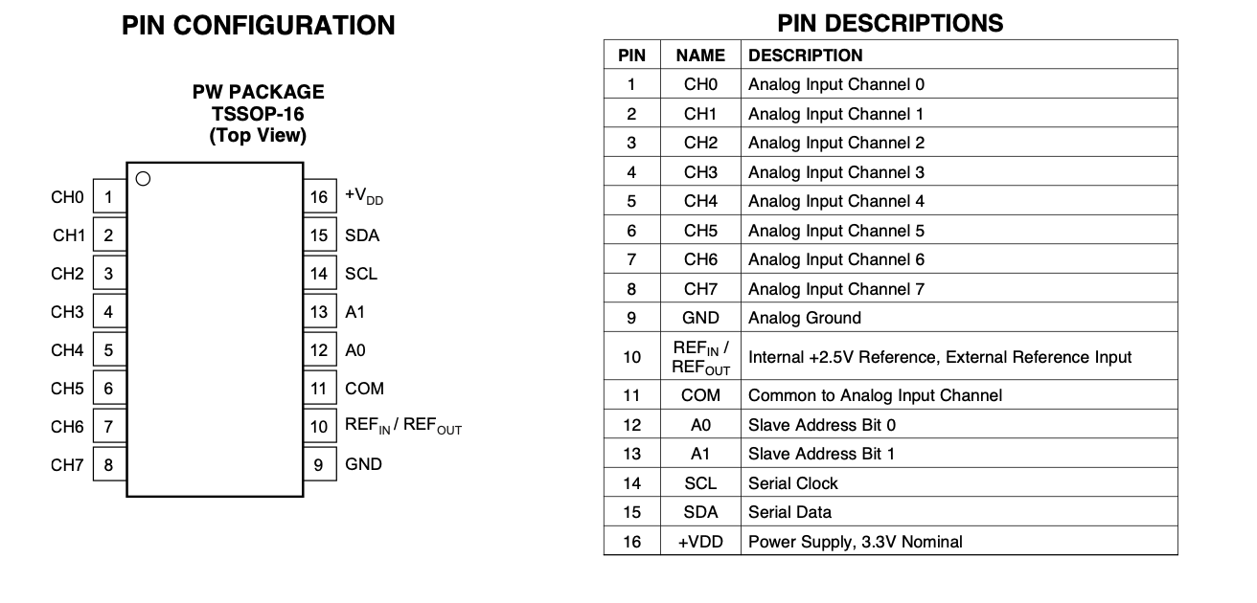

10k potentiometer:
Resistance & Tolerance = 10kΩ (dual-gang 100kΩ) + not stated assume +- 20%,
For filter accuracy so have to add a tolerance value to code
Taper = Linear + logarithmic,
for the filter curve mapping
Shaft diameter & type = 16mm t-18,
for the knob fit
Thread size + panel hole size = ??
Body depth below panel = ??? need to measure

DPDT toggle switches:
Which lugs apply to what position =
Check it with your multimeter, which takes about 5 minutes:
Set the multimeter to continuity, the setting that beeps when two points are connected.
Hold the switch with its lugs facing you and label the lugs on a sketch: left column top, middle, bottom, and right column top, middle, bottom.
Put the lever up. Touch one probe to the left middle lug, then touch the other probe to the left top lug, then the left bottom lug. Note which one beeps.
Repeat with the lever in the middle, then down.
Fill in a table with lever position against what beeps. It should show: up gives one end, middle gives neither, down gives the other end.
Check the right column gives the same pattern. Top + bottom to diff pico pins bot set to INPUT_PULLUP
Panel hole size = 6mm

3.5mm Jack:
Tip pin = end of plug, usually left channel to audio signal Base of plug, ground
Ring pin = usually band between tip + sleeve, normally right to audio signal
Sleeve pin = Base of plug, ground
Switch pins = for tip + ring, leave disconnected
Mounting style =
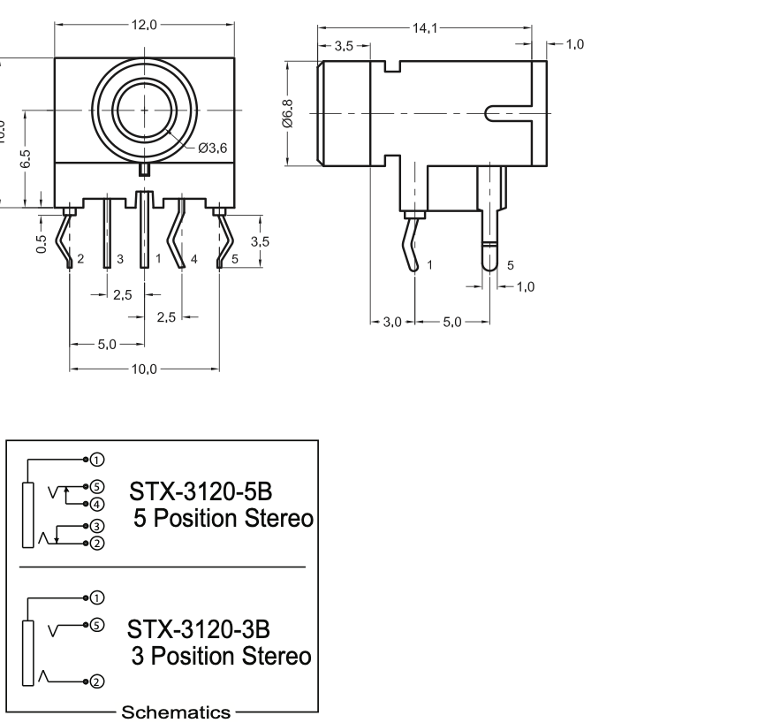

Capacitors:
Ceramic working voltage = <63V
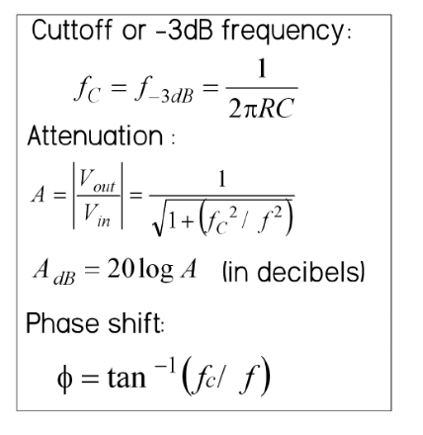 (to find cutoff frequency of coupling capacitors)
For bypassing:
As a general rule of thumb, the impedance of the bypass capacitor should be
10 percent of the input impedance of the circuit element.

